

The Peples Republic of Bangladesh
Minstry of Health &Family Welfare (Health Service Division)
Health Economic Unit (HEU). Shasta Surakkha Kormochuci(SSK).
Topkhana Road, Dhaka-1000

Visit Report: Sakhipur Upazilla Health Complex,Tangail& Meeting with Civil Surgeon,Tangail.
Date of Visit: 18/07/22. AT 9-30AM.
Visitor: Mr.Azmal Kabir, National Consultant (HEU) of MoHFW.&
Dr.Md. Emdadul Haque, National Consultant (HEU) of MoHFW.

1.Admistrative discussion: Discussion with Dr. Ruhul Amin, UH&FPO, RMO and other MOs about activites of the UHC, Sakhipur and its latest situation. The hospital is 50 bedded. Regarding attendance, accoding to the analysis of thumb impression, it was obserbed that with few exceptions most of the Consultants and MOs come and checked out in time.

2. A meeting held with UHFPO, RMO and Medical Officers,Nurses at Sakhipur UHC on 18July,2022at their conference room about SSK activities, responsibilities of each group &challengesin impllimentatiom SSK program.
3. We visit the SSK booth & pharmacy –Pharmacy yet not established due to construction defect. We inform it to the contractor to take immediate actions.
4. We visit the emergency deptt. Indoor and observe the Cleanliness of the toilets.

In evening : We meet with the Civil surgeon & Deputy Civil Surgeon of Tangail district.We discuss about the components of Chowgacha models & replication of C-J model in different UHC of Tangail district.They assuered us for replication.
We request to Civil Surgeon that,Program Manager of SSK, Tangail district will participate in mon thly co ordination meeting at Civil Surgeon office.He agree with the proposal.

VisitReport: ModhupurUHC, GopalpurUHC &
BhuapurUHC ,Tangail,.
Date of Visit: 19/07/22. AT 9-30AM.
Visitor: Mr.Azmal Kabir, National Consultant (HEU) of MoHFW.&
Dr.Md. Emdadul Haque, National Consultant (HEU) of MoHFW

Modhupur UHC:It is 100 beded UHC having administrative order to start the UHC.They start with local initiative.The health complex is running with 50 beded manpower.Male,Femle, pediatric word shifted in new building. The building is 5 storeyed.Alft is there but ther is no lift man.They need 5 cleaner or guard .
A meeting was held at new conference room .UH&FPO ,RMO,other Medical Officers,nurses.were preset there.Building blocks of C-J model was discuss there.They are interested to replicate the model.
Wevisited the indoor. In OPD, NCD Corner ANC Corner,VIA Corner,& Emergency Deptt. Give observation report.We leave theUHC 12.30PM.

Sl No | Site of vsit | Result | Request for action
1 | Emergency Deptt | Wide space ,clean, good infection control system, Privecy is not maintained properly. | UH&FPO
2 | Health education sym . | No health education system | Request for action
3 | Beautiful gardening but area at the entrance in hospitalcampus is not clean. | Beautiful | 30 Day
4 | Improve information display in emergency, IMCI-Corner, ANC-Corner, indoor&EOC Word. | Incharge of respective dept./RMO/UH&FPO | 30 Day
5 | Removal of unwanted items from EOC -OT | OT-incharge/Anesthesiologist/  RMO | 10 Day
1.Admistrative discussion: Discussion with Dr. Ruhul Amin, UH&FPO, RMO and other MOs about activites of the UHC, Sakhipur and its latest situation. The hospital is 50 bedded. Regarding attendance, accoding to the analysis of thumb impression, it was obserbed that with few exceptions most of the Consultants and MOs come and checked out in time.

2. A meeting held with UHFPO, RMO and Medical Officers,Nurses at Sakhipur UHC on 14July,2022at their conference room about SSK activities, responsibilities of each group &challengesin impllimentatiom SSK program.
3. We visit the SSK booth & pharmacy –Pharmacy yet not established due to construction defect. We inform it to the contractor to take immediate actions.
4. We visit the emergency deptt. Indoor and observe the Cleanliness of the toilets.

In evening : We meet with the Civil surgeon & Deputy Civil Surgeon of Tangail district.We discuss about the components of Chowgacha models & replication of C-J model in different UHC of Tangail district.They assuered us for replication.
We request to Civil Surgeon that,Program Manager of SSK, Tangail district will participate in mon

Action plan of Chowgacha UHC, Jashore. for solving the problames (Tentative & Changeable by the local authority)
Sl No | Components | Responsibilities | Duration
1 | Improvement of Infection control system in emergency. | EMO in Charge /RMO | 05 Day
2 | Starting of Health education system in front of emergency | EMO in charge/RMO | 15 Day
3 | Writing of health massage on pana &apply on billboards | RMO/UH&FPO | 30 Day
4 | Improve information display in emergency, IMCI-Corner, ANC-Corner, indoor&EOC Word. | Incharge of respective dept./RMO/UH&FPO | 30 Day
5 | Removal of unwanted items from EOC -OT | OT-incharge/Anesthesiologist/  RMO | 10 Day
6 | Improvethe birth-death recor-  dingsystem | SI/MO(DC), UH&FPO | 45 Day
7 | Starting of 5S KAIZEN-TQM | QIC Team/UHFPO | 15 Day
8 | Ensuring attendance of all govt. officers and staffs in time. | UH&FPO | 15 days.
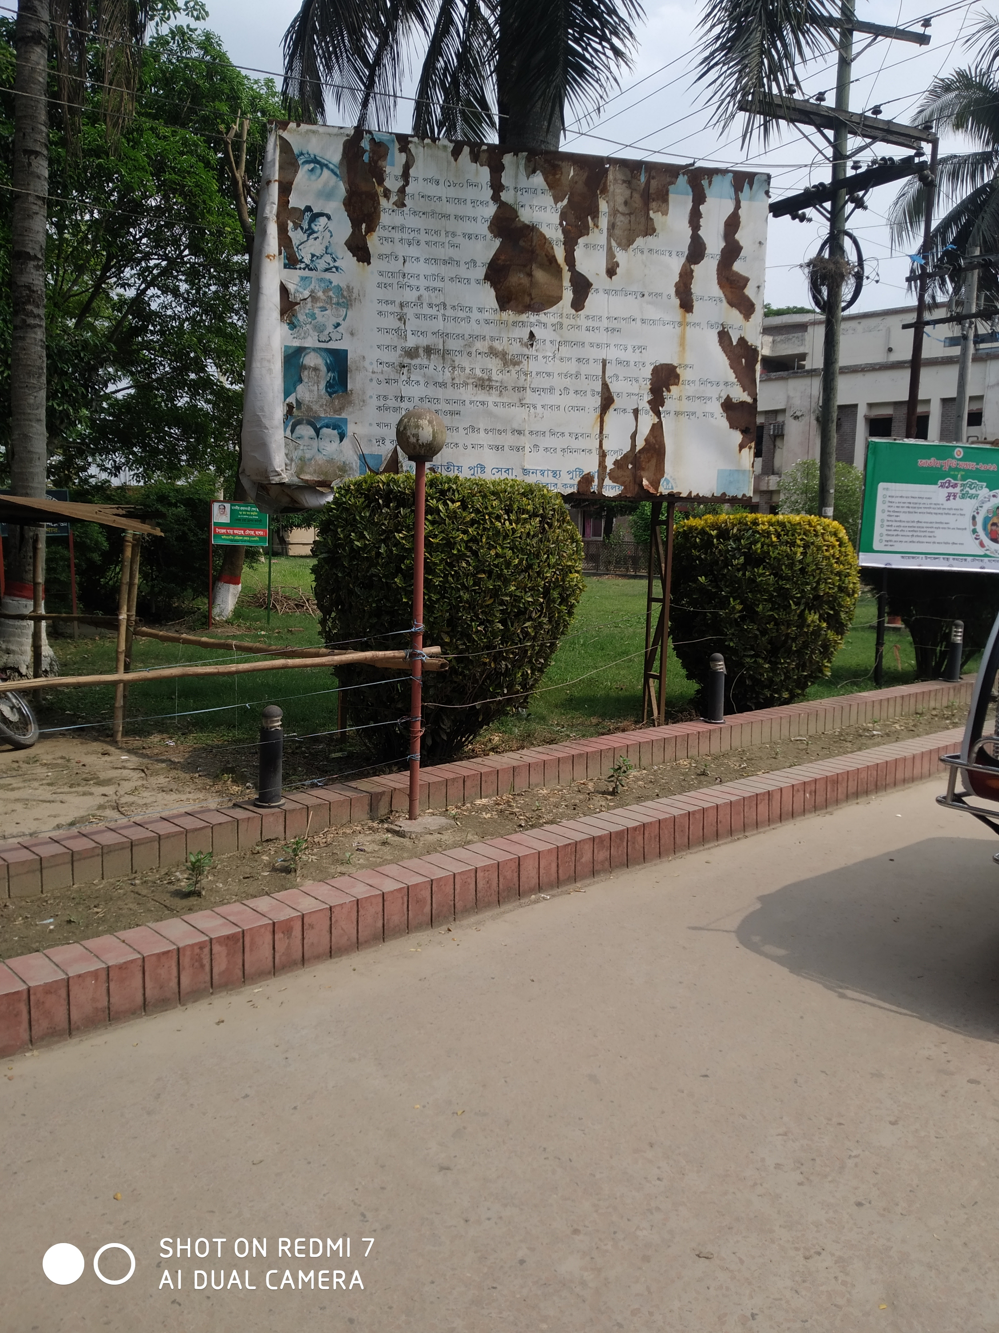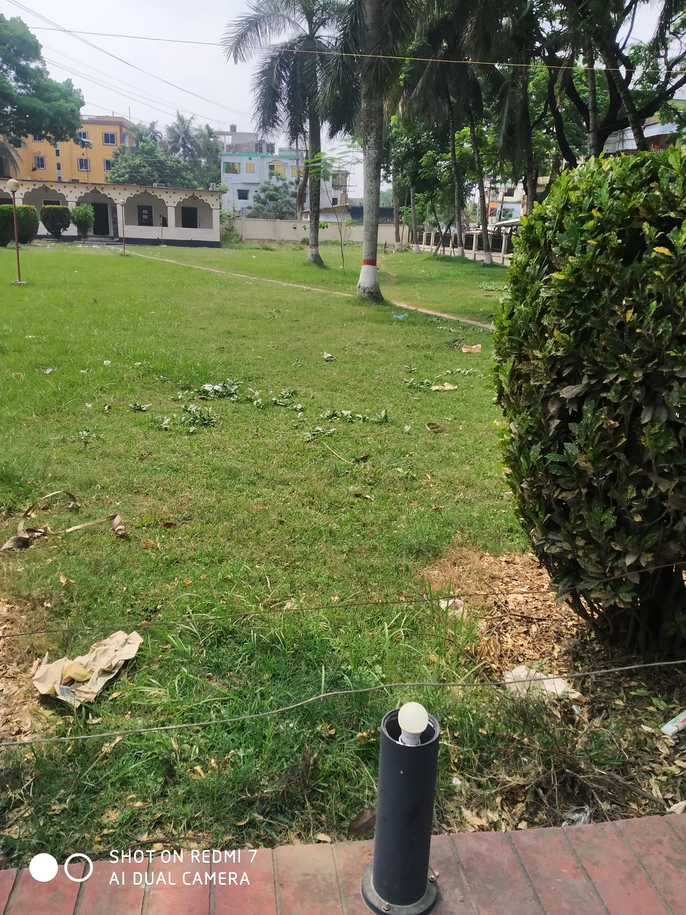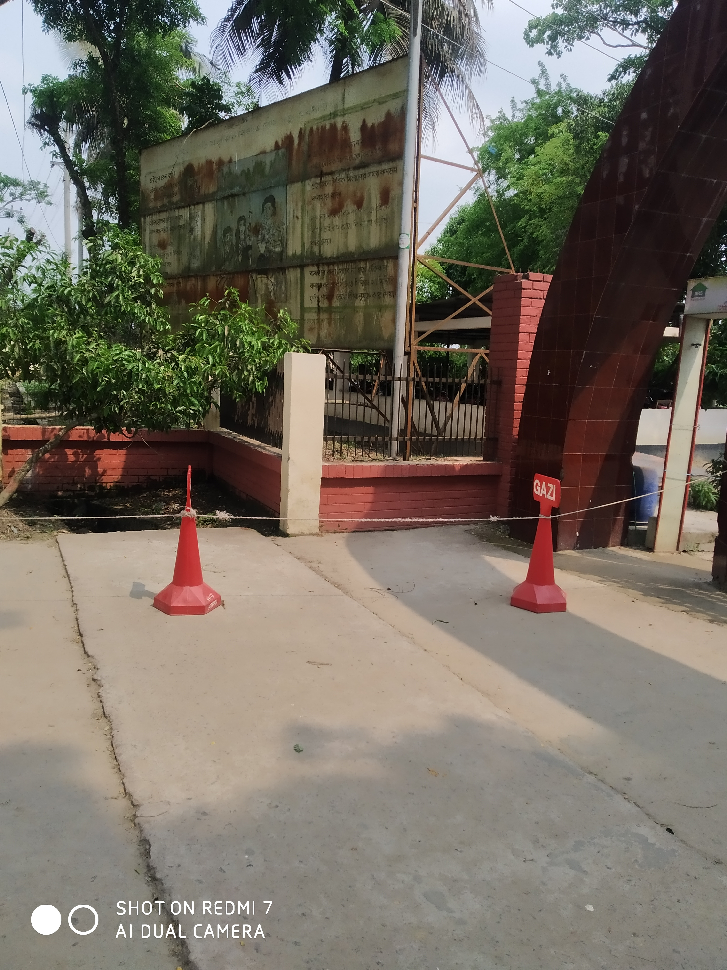

- Important Human Resource :
Sl No | Post | Allocated Post | Filled | Vacant | Comment
1 | UH&FPO | 1 | 1 | 0
2 | RMO | 1 | 1 | 0 | In-charge
3 | Consultants | 10 | 2 (Anesth, Ortho) | 8
4 | MO/Asst Surgeon (UHC + UnionH&FWC). | 20 (9+11) | 13 (5+8) | 7 (4+3)
5 | Nurse and Midwife | 36 (32+4) | 34 | 2
6 | SACMO (Health Complex + Union ( H & FWC) | 15 (2+13) | 11 | 4
7 | Head Assistant | 1 | 0 | 1
8 | Accountant | 1 | 0 | 1
9 | Casheer | 1 | 0 | 1
10 | HI + AHI + HA | 43 | 21 (0 + 0 + 21) | 22
11 | MLSS (UHC + Union H&FWC) | 8 (4+4) | 2 (1+1) | 6 (3+3)
12 | Word Boy+Aya | 5 | 2 | 3
13 | Cleaner | 5 | 2 | 3
SL.No. | Post | Allocated Post | Fill up | Vacant | Comment
14 | MT(Lab) | 3 | 1 | 2
15 | Pharmacist (UHC + Union) | 6(2+4) | 2(2+0) | 4
16 | Total Human Resource | 209 | 137 | 72
17 | 1st Class | 32 | 18 | 14
18 | 2nd Class | 39 | 38 | 1
19 | 3rd Class | 112 | 70 | 42
20 | 4th Class | 26 | 11 | 15
21. | Community Supported Manpower |  | 26

Chowgacha h
নং | কর্মসূচি | বাস্তবায়নকারী | সময়সীমা
 | কমিউনিটি সহায়তা কমিটি গঠ্ন | স্থানীয় হাসপাতাল/উপজেলা স্বাস্থ্য কমপ্লেক্স কর্তৃপক্ষ | ১৫ দিন
 | প্রাথমিক মূল্যায়ন প্রতিবেদন প্রস্তুতকরণ | কিউআইসি ও ডাব্লুআইটি দল | ৩০ দিন
 | সমস্যাসমূহ চিহ্নিতকরণ | কিউআইসি ও ডাব্লুআইটি দল | ৩০ দিন
 | দূরদৃষ্টি, লক্ষ্য এবং লক্ষ্যমাত্রা নির্ধারণ | কিউআইসি দল | ১৫ দিন
 | লক্ষ্যসমূহ বাস্তবায়নে জনগোষ্ঠী ও সেবাদানকারীদের অঙ্গিকার অর্জনে কর্মশালার মাধ্যমে উদ্বুদ্ধকরণ | স্থানীয় হাসপাতাল/উপজেলা স্বাস্থ্য কমপ্লেক্স কর্তৃপক্ষ | ৯০ দিন
 | প্রয়োজনীয় সামগ্রীর তালিকা প্রস্তুত ও সংগ্রহ | স্থানীয় হাসপাতাল/উপজেলা স্বাস্থ্য কমপ্লেক্স কর্তৃপক্ষ | ১৮০ দিন

Institutional implementation Action plan
Sl No | Components | Responsibilities |  | Duration
1 | Infection prevention in emergengcy | EMO/RMO |  | 5 Day
2 | Health education in o | QIC and WIT team |  | 30 Day
3 | Identification of Problems | QIC and WIT team |  | 30 Day
4 | Determining the vision, goals and goals | QIC team |  | 15 Day
5 | Motivation through the workshop to achieve the commitment of the people and the service providers to implement the goals | Local Hospital/ Upazilla Health Complex Authority |  | 90 Day
6 | Preparation and collection of necessary materials | Local Hospital/ Upazilla Health Complex Authority |  | 180 Day
7 | Prepare policies for building value-based work-environment a institutional culture | QIC Team |  | 15 Day
8 | Communication with all stakeholders to develop social movements to achieve the goal | Community Support Group and Local Health Authority | 60 Day
9 | Training on quality development 5S KAIZEN-TQM. | Local Health Authority | 7 Day
10- | Achieve practical knowledge through a team visiting the Chowgacha UHC and Jhenaidah Sadar Hospital | National Technical Committee | 3 days

